**Erwil Agbon**

**Reynaldo De Guzman**

**Nelben T. Acebo**

**Danica Mae Balandra**

**Ohara Michelle Elloren**

**Mary Stephanie Torrion**

**Deoruss Maglacion**

**Keith Jacka Degamon**

**Mykel Glenn Geronimo**

**Maribeth Caballes**

**Kyla Faith L. Modio**

**Andrea Cecille B. Siodina**

**Noel Cayunda**

**Kevin Jan Alud**

**Rizel Joy Bain**

**Marvin Cimagala**

**Ken Perez**

**Jessalyn Legaspi**

**Gwyneth Franzyn Ledesma**

**Jean Laurente**

**Kristine Salvado**

**Joy Antecristo**

**Mae Ann Sator**

**Ronalyn Pencito**

**Maricris Abina**

**Christina Lumayag**

**Lara Jane Saragena**

**Sunshine Menosa**

**Francis Anne Erolon**

**Jomari Constantino**

**Precious Justine Garay**

**Catherine Jean Cutamora**

**Joy Baladiang**

**Vanessa Angelou Cabardo**

**Raven Lerio**

**Edwin Baldemor**

**Shaila Lubas**

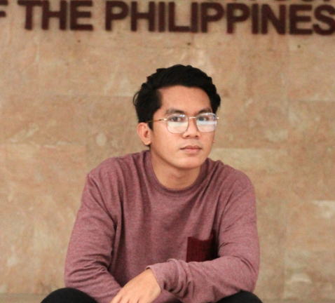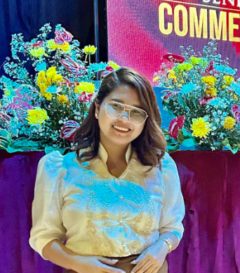

**Romelyn Bitayo**

***OSA Head***

**Erwil Agbon**

***SSC Adviser***